
Preliminary/Internal
Incident Investigation Report
Disclaimer: This document is intended to be a resource document only. The farm will need to customize it and make it farm-specific to address the particular needs, factors, applicable legislated requirements, etc. Once this document has been customized by the farm, this disclaimer, the Helpful Information section, and the logo located in the upper right corner of the page may be deleted and replaced with the farm’s logo. If you require assistance, please contact AgSafe Alberta at info@agsafeab.ca or visit www.agsafeab.ca for learning opportunities, tools and resources.
Section 1: Incident Notification
Farm Name: |  |  | Incident Date & Time: |  |  | Notification Date & Time:
Person Reporting Incident: |  |  | Contact Telephone:
Contact Address: |  |  | Contact Email:
Incident Took Place: | ☐ Farm Location ☐ Client Location ☐ In-Transit ☐ Other Location
Location Name, Address and Details:

Description of Incident:
Include all relevant events that happened prior to the incident, during the actual incident and immediate actions that followed the incident. Provide the who, what, when, where, why and how information. Use additional paper when needed.

Weather: | ☐ Clear | ☐ Hail/Sleet |  | ☐ Rain | ☐ Snow | ☐ High Wind |  | ☐ Fog/Smog
Temperature: | ☐ _______C | ☐ Wind Speed: |  | ☐ Wind Direction: | ☐ Wind Chill:
Road/Surface Condition: | ☐ Dry | ☐ Wet |  | ☐ Muddy | ☐ Snow/Ice | ☐ Slippery |  | ☐ Rut/Bump
 | ☐ Oily | ☐ Soft |  | ☐ N/A | ☐ Other:
Visibility: | ☐ Daylight | ☐ Sun Glare |  | ☐ Dark | ☐ Dim | ☐ Adequate
Incident Photographs: | ☐ Yes | ☐ No |  | Incident Photographs Given To:
Sketch of Scene: | ☐ Yes | ☐ No |  | Incident Sketch Sent To:

Could this be a: | ☐ Serious Incident |  |  | ☐ Potentially Serious Incident |  |  | ☐ Not Applicable
Incident Type: | ☐ Incident (loss incident) | ☐ Near Miss (no loss incident) |  |  | ☐ Hazard Report |  | ☐ Report Only
Incident Subtype: | ☐ Fatality |  | ☐ Serious/disabling injury |  |  | ☐ Injury (first aid or medical aid)
 | ☐ Wildfire |  | ☐ Equipment damage |  |  | ☐ Work related Illness
 | ☐ Equipment fire |  | ☐ Property damage |  |  | ☐ Environmental spill/release
 | ☐ Structure fire |  | ☐ Motor vehicle incident |  |  | ☐ Other:
*For a non-occupational illness report, complete only the applicable portions of Section 1, 2 & 5.

Was a Safety Rule, Procedure or Practice Violated? ☐ Yes ☐ No
If Yes, describe the violation & reference the applicable policy, standard or procedure and section.

What documentation is attached?
☐ Hazard Assessment(s) | ☐ Training Records | ☐ Orientation Records | ☐ Witness Statement(s)
☐ Maintenance Record(s) | ☐ List other items in the space below:

Section 2: Involved or Witnessing Parties
First & Last Name | Trade/Occupation | Position | Employer
Include a written statement from each involved or witnessing party.

Section 3: Injured Person Information (For multiple injuries, copy and paste this section)
First & Last Name of Injured Person | Position/Trade/Occupation |  | Notes
Details of Injury/Injuries:

Number of consecutive days worked prior to the incident:
Part(s) of Body Injured:
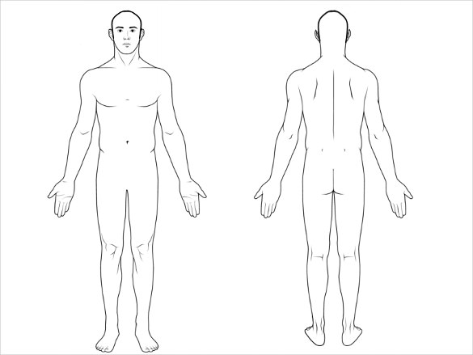 | Injury Type/Source:
 | ☐ Abrasion, Scratch | ☐ Allergic Reaction |  | ☐ Amputation
 | ☐ Animal Bite | ☐ Asphyxiation, Suffocation |  | ☐ Avulsion, deglove
 | ☐ Blister | ☐ Burn: Chemical |  | ☐ Burn: Electrical
 | ☐ Burn: Heat | ☐ Bruise, Contusion |  | ☐ Crush Injury
 | ☐ Cut, Laceration | ☐ Dislocation |  | ☐ Electrocution
 | ☐ Fall: higher level | ☐ Fall: same level |  | ☐ Fall: Other
 | ☐ Fracture | ☐ Foreign Body, Splinter |  | ☐ Friction Burn
 | ☐ Frostbite | ☐ Heat Stroke |  | ☐ Heat Syncope
 | ☐ Hypothermia | ☐ Insect Bite/Sting |  | ☐ Poison: Gas, Vapour
 | ☐ Self Harm | ☐ Radiation |  | ☐ Poison: Other
 | ☐ Sprain/train/Tear | ☐ Struck: Caught Between |  | ☐ Struck: Falling Object
 | ☐ Traumatic Shock | ☐ Violence: Bodily Force |  | ☐ Violence: Other

Section 4: Environmental Release
Material Released: | Mass/Volume Released:
Material Released: | Mass/Volume Released:

Section 5: Equipment Damage
Equipment Name/Type: | Equipment Name & Unit No.:
Serial or VIN Number: | Description of Damage:
Equipment Name/Type: | Equipment Name & Unit No.:
Serial or VIN Number: | Description of Damage:

Section 6: External Agency Reporting
Lost Time Days: ☐ Yes ☐ No | No. of Days: |  | Modified Work: ☐ Yes ☐ No |  |  | No. of Days:
Does the incident criteria require outside agency reporting? ☐ Yes ☐ No
Agency Reported To: |  | Time/Date: |  | Reported By: | Notes:
Workers Compensation Board
Insurance Company
Alberta Occupational Health and Safety
Alberta Environment
Other:
Other:

Section 7: Immediate Causes
Were there any unsafe or substandard acts? If so, list and explain how they contributed to the incident. | Were there any unsafe or substandard conditions? If so, list and explain how they contributed to the incident.

Section 8: Root Cause(s)
Complete the 5 Why’s Root Cause Analysis method as many times as necessary. List the root causes identified below.

Section 9: Corrective Actions
Immediate Actions Taken | Assigned To  (First & last name, position) | Goal  Date | Date Completed
Recommended Corrective Actions | Assigned To  (First & last name, position) | Goal  Date | Date Completed

Section 10: Investigation Team Members
Last Name | First Name | Position/Title | Employer
a.

Signature: |  | Date:
b.

Signature: |  | Date:
c.

Signature: |  | Date:
d.

Signature: |  | Date:

Section 11: Senior Management/Leadership Review
Last Name | First Name | Position/Title | Employer
a.

Signature: |  | Date:
b.

Signature: |  | Date:
c.

Signature: |  | Date:
d.

Signature: |  | Date:

Important: Retain a copy of this document in your farm records.

