Job Task hazard assessment form

Job or Task | Operate powered mobile equipment
Details | Job or task is done by the farm team members  Job or task is done by a service provider or contractor  Not applicable to the farm/the farm does not use powered mobile equipment
Farm Name |  |  |  |  |  | 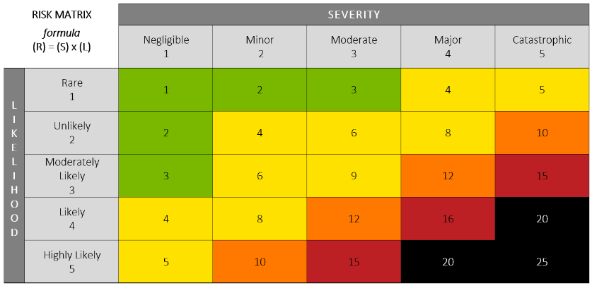
Completed By
Date Completed |  | Review Date

Task or Step | Possible Hazards & Outcomes | S | L | R | Hazard Controls In Place
Get in and out of powered mobile equipment | Health Hazards:  Other:  Safety Hazards:  Weak grip, slippery step in  Other:  Possible Outcomes:  Loss of balance, fall  Other: |  |  |  | Engineered Controls:  Handles for getting in and out  Other:  Administrative Controls:  Person must be trained and competent in this task  Use handles for getting in and out  Maintain 3 points of contact for getting in and out  Do not have other items in your hands when getting in and out  Keep soles of boots clean/scraped  Other:  Personal Protective Equipment:  Footwear with good grips  Other:
Fuel powered mobile equipment | Health Hazards:  Fumes, fuel contact with skin  Other:  Safety Hazards:  Static electricity and sources of electricity, slippery or rutted and uneven ground, fuel spill  Other:  Possible Outcomes:  Fire or explosion, slip or trip, fall, respiratory irritation, skin irritation, chronic exposures to fuel can lead to cancer  Other: |  |  |  | Engineered Controls:  Automatic shut-off on fuel pump  Dike present around fuel tank/refueling area  Other:  Administrative Controls:  Person must be trained and competent in this task  Turn skid steer off when refueling  Do not smoke, use a mobile phone, or other sources of ignition  Do not re-enter or exit powered mobile equipment during refueling without grounding yourself by touching a metal surface with a bare hand first  Metal gas nozzle is always in contact with the lip of the tank during refueling to eliminate static build up  A fully stocked spill kit and/or tray is kept at the refueling area  Stand upwind during refueling  Other:  Personal Protective Equipment:  Coveralls  Chemical resistant gloves  Chemical resistant boots  Other:
Operate powered mobile equipment | Health Hazards:  Noise, sitting for long periods, repetitive movements  Other:  Safety Hazards:  People or animals in the work area, equipment or buildings in the work area (limited room to move), poor lighting, poor visibility, steep grades, extreme temperatures  Other:  Possible Outcomes:  Hearing damage, soft tissue injury, roll over, run over, contact with buildings or equipment, heat/cold stress  Other: |  |  |  | Engineered Controls:  Adjustable seat  Backup alarm  Backup camera  Other:  Administrative Controls:  Person must be trained and competent in this task  Pre-inspect equipment before use; conduct function tests of lights and safety features (i.e., running lights, backup alarm, etc.)  Keep lights clean  Adjust seat prior to use & wear seatbelt at all times  Before starting work, inspect work area for ground or slope hazards, overhead hazards, visibility issues, etc. and eliminate or control them  Operate at a safe speed  When travelling, keep load as close to the ground as reasonably possible  Use a trained and properly equipped Spotter  Stop equipment if visual contact with Spotter or other(s) is lost  Rope, flag, post signs or use other methods to keep people out of the work area  Check weather report prior to starting work; dress for conditions and schedule breaks appropriately  Other:  Personal Protective Equipment:  Hearing protection, if appropriate  Spotters/other workers wearing high visibility and retroreflective vests and gloves  Other:
Operate powered mobile equipment | Health Hazards:  Noise, sitting for long periods, repetitive movements  Other:  Safety Hazards:  People or birds in the work area, equipment or buildings in the work area (limited room to move), poor lighting, poor visibility, steep grades, extreme temperatures, overhead hazards  Other:  Possible Outcomes:  Hearing damage, soft tissue injury, roll over, run over, contact with buildings or equipment, heat/cold stress  Other: |  |  |  | Engineered Controls:  Adjustable seat  Backup alarm  Backup camera  Other:  Administrative Controls:  Person must be trained and competent in this task  Pre-inspect equipment before use; conduct function tests of lights and safety features (i.e., running lights, backup alarm, etc.)  Keep lights clean  Adjust seat prior to use & wear seatbelt at all times  Before starting work, inspect work area for ground or slope hazards, overhead hazards, visibility issues, etc. and eliminate or control them  Operate at a safe speed  When travelling, keep load as close to the ground as reasonably possible  Use a trained and properly equipped Spotter  Stop equipment if visual contact with Spotter or other(s) is lost  Rope, flag, post signs or use other methods to keep people out of the work area  Check weather report prior to starting work; dress for conditions and schedule breaks appropriately  Other:  Personal Protective Equipment:  Hearing protection, if appropriate  Spotters/other workers wearing high visibility and retroreflective vests and gloves  Other:

Load, pick up, set down and unload | Health Hazards:  Other:  Safety Hazards:  Load shifting, blind spots, line of sight problems dropped load, material too heavy for the equipment, unbalanced load  Other:  Possible Outcomes:  Run over, roll over, dropped load, contact with objects or building, contact with equipment  Other: |  |  |  | Engineered Controls:  Other:  Administrative Controls:  Person must be trained and competent in this task  Know the maximum allowable load limits as per the manufacturer’s specifications  Ensure the load is balanced  Strap and secure the load properly; cradle the back of the load slightly  Other:  Personal Protective Equipment:  Well fitting gloves with good grip  Steel toe footwear  Other:

Additional Comments, Refence Documents, Etc.

Print Name | Print Job Title | Signature | Date

Important: Retain a copy of this document in your farm records.

