hazard assessment form

Job or Task |  |  |  | Risk Matrix
 |  |  |  | 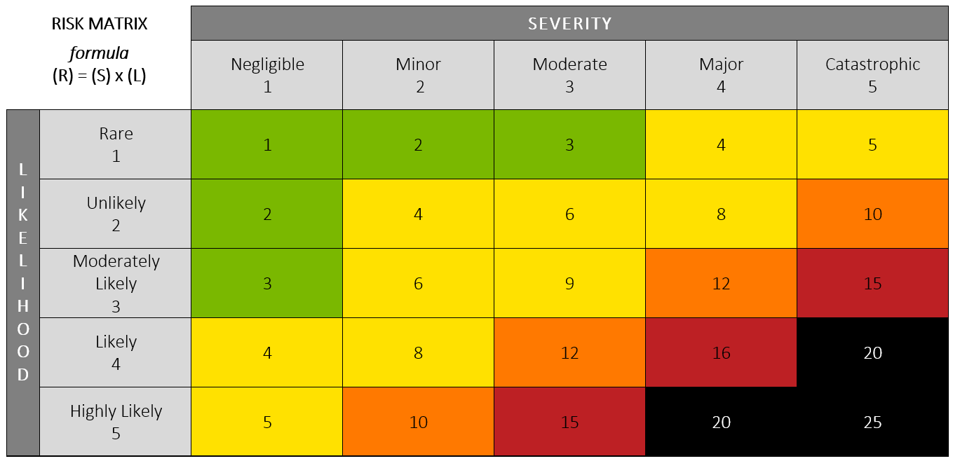
Farm Name
Completed By
Date Completed |  | Review Date

Task/Step | Hazards | Risk Rating | Hazard Control Measures

Additional Comments, Refence Documents, Etc.

Print Name | Print Job Title | Signature | Date
Important: Retain a copy of this document in your farm records.

